- Linux commands

pwd - present working directory
cd - change directory
cd .. - one step back
cd ../.. two steps back
ls - list
ls -l list long
ls -a list of files+hidden files
ls -la hidden files+ long list
ls -lS list of files in sorting format(Higher volumes to lower)
ls -d */ list all the directories only

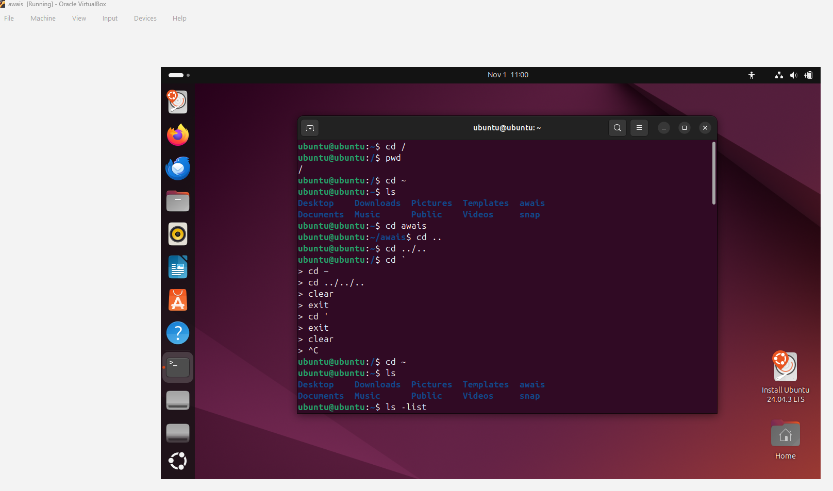

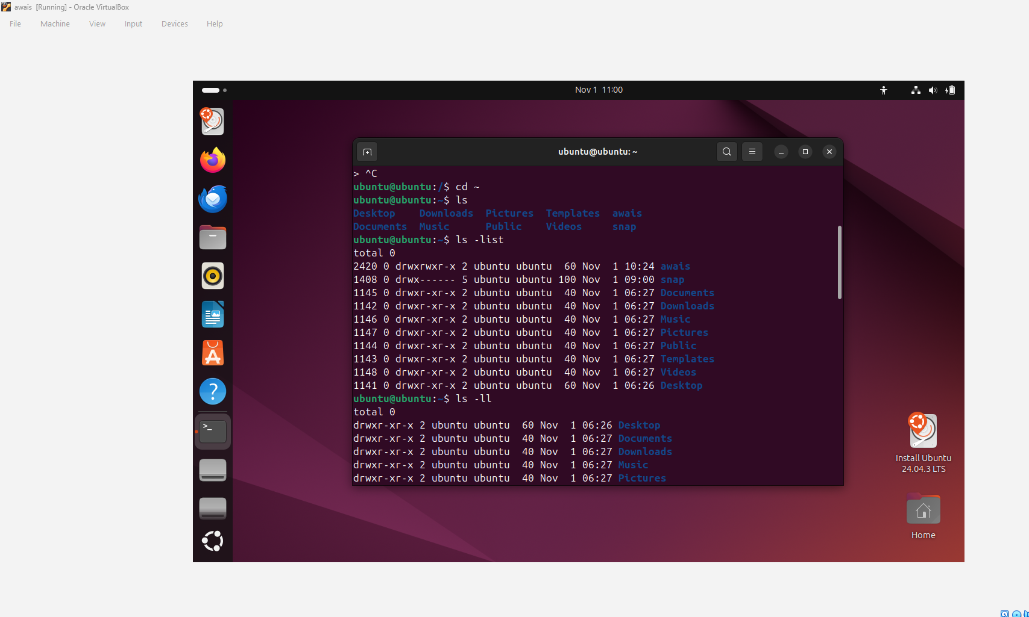

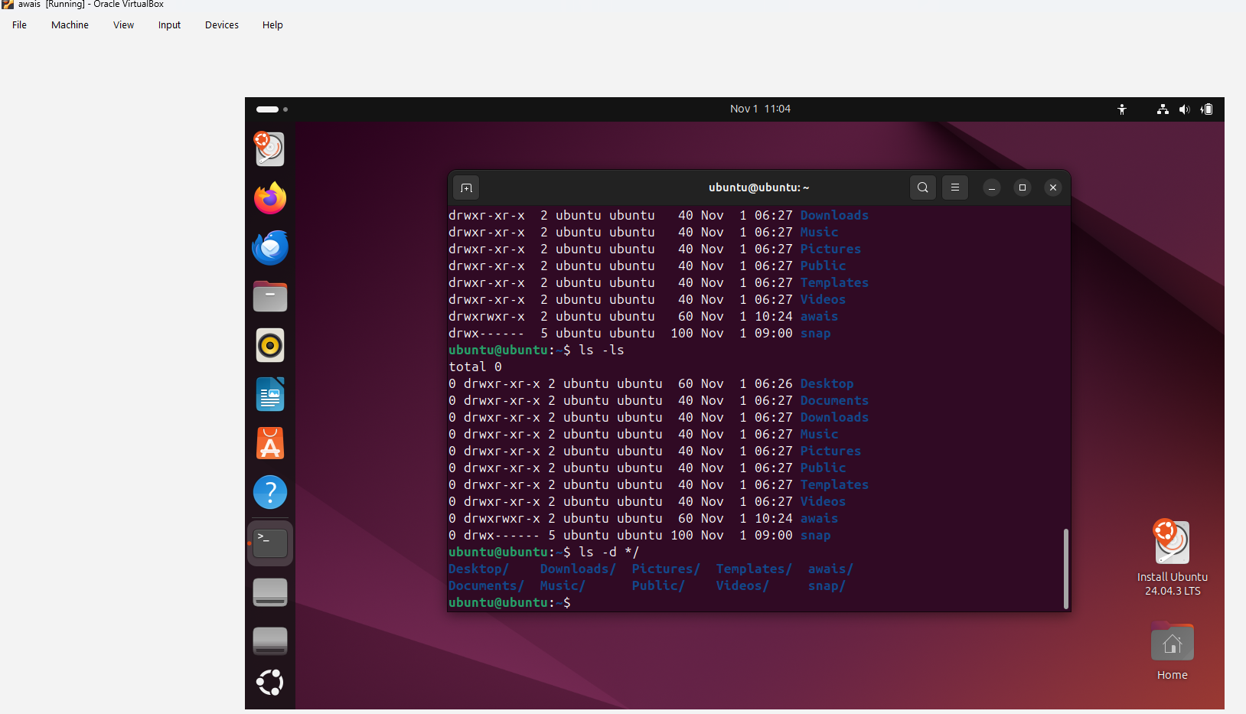

Mkdir : to create new files
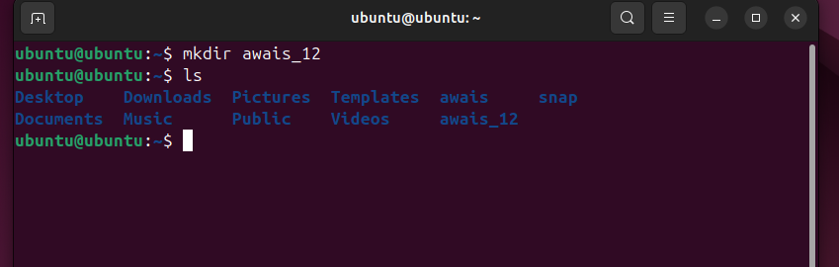
Mv file name .file name to hide that file
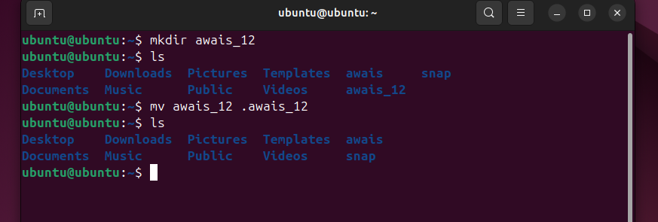
Ls -a :To see hidden files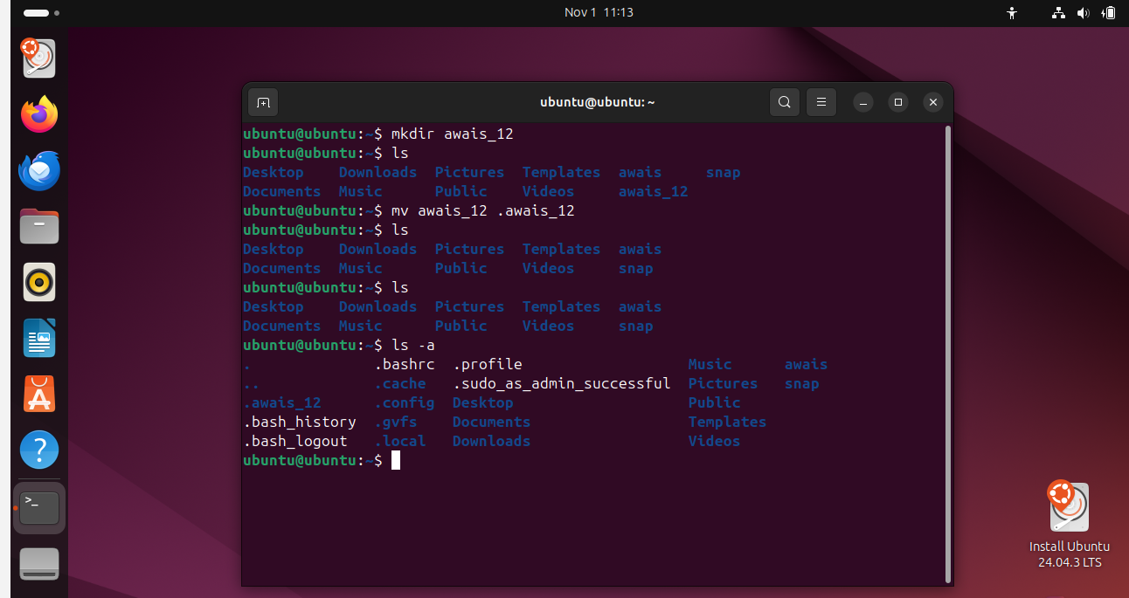
mv .filename filename : to unhide the file 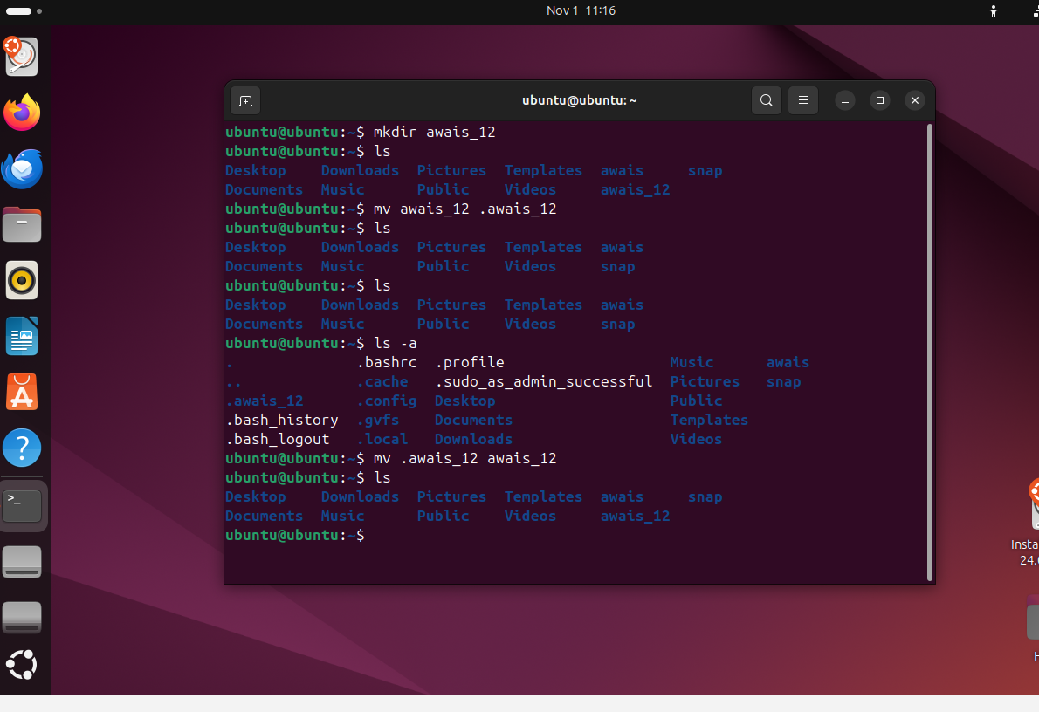
rm -rf filename : to delete the file
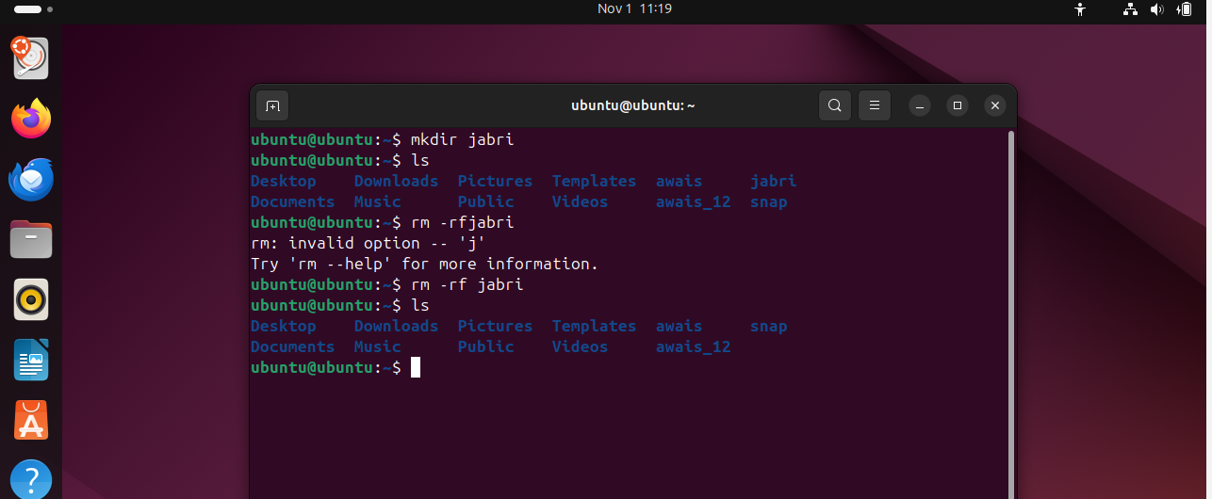
mv file name /path : to move the files in path
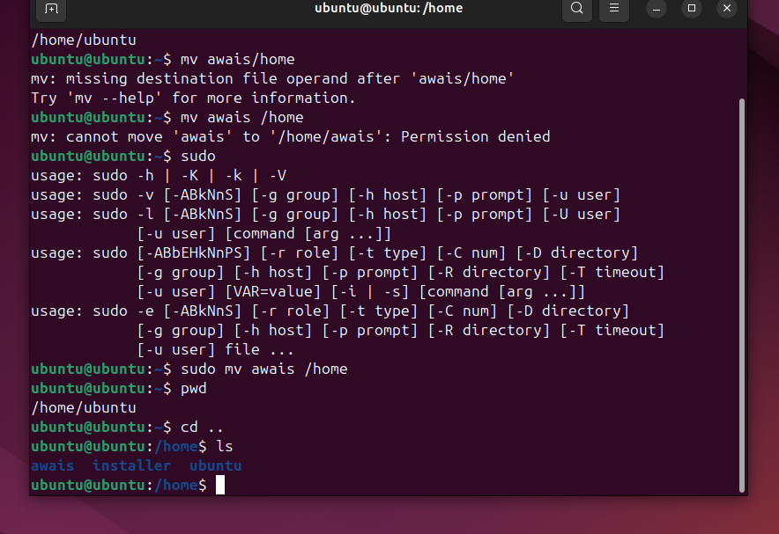
cd filename then touch : to create new sub file
VI : to able to add some content in the file
:wq! :to save the editing
cat file name : to able to view the content
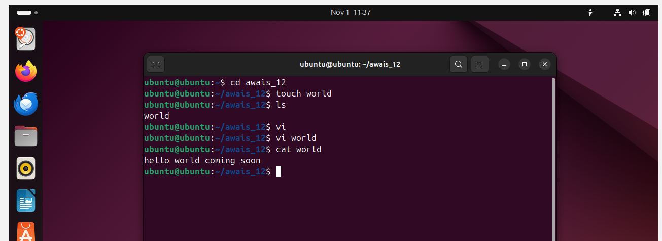
wc filename : to get the details of your file

